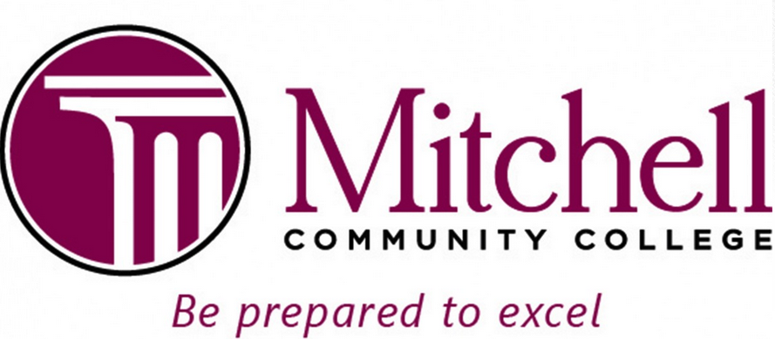

Financial Aid Office Revised 6-12-18
500 West Broad Street
Statesville, North Carolina 28677

2018-2019 Federal Work-Study Interest Form

The Federal Work-Study Program provides eligible students with job opportunities on campus. Schedules are flexible and work around your class schedule. Students typically work up to 15 hours per week, based on the student’s class schedule and department needs. Our on-campus work-study positions pay $8.25 per hour. Paychecks are mailed monthly for the hours worked the previous month.

Jobs are assigned from the Financial Aid Office in conjunction with various campus departments. If you are interested in participating in Federal Work-Study, please provide the information below and return this form to Mark West in the Financial Aid Office located in the Student Services Center (Eason Building), Room 205, 2nd floor. Priority is given on a first come, first serve basis. Students must have a current and completed 18/19 FAFSA on file with Mitchell Community College and be eligible for Title IV funding.

Thank you!
Mark West
Financial Aid Specialist / Federal Work-Study Coordinator

Equal Opportunity College
An Affirmative Action Employer

Print Name ___________________________________ Campus Location (Statesville or Mooresville)?_____________

Day Telephone_________________________________ Alternate Telephone_________________________________

MCC Student ID #_______________________________ Major/Program of Study______________________________

Work Experience____________________________________________________________________________________

__________________________________________________________________________________________________

